**BASIC UNIX COMMANDS**

1. **cat**

cat > ishanki command is used to write into a file.

cat ishanki displays the file on your screen.

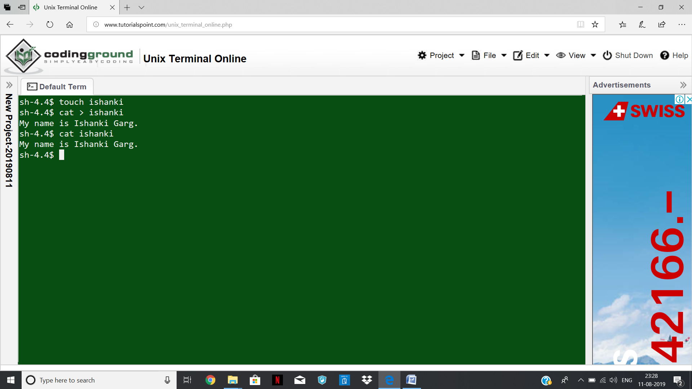

1. **pwd**

It is used to report your current working directory.

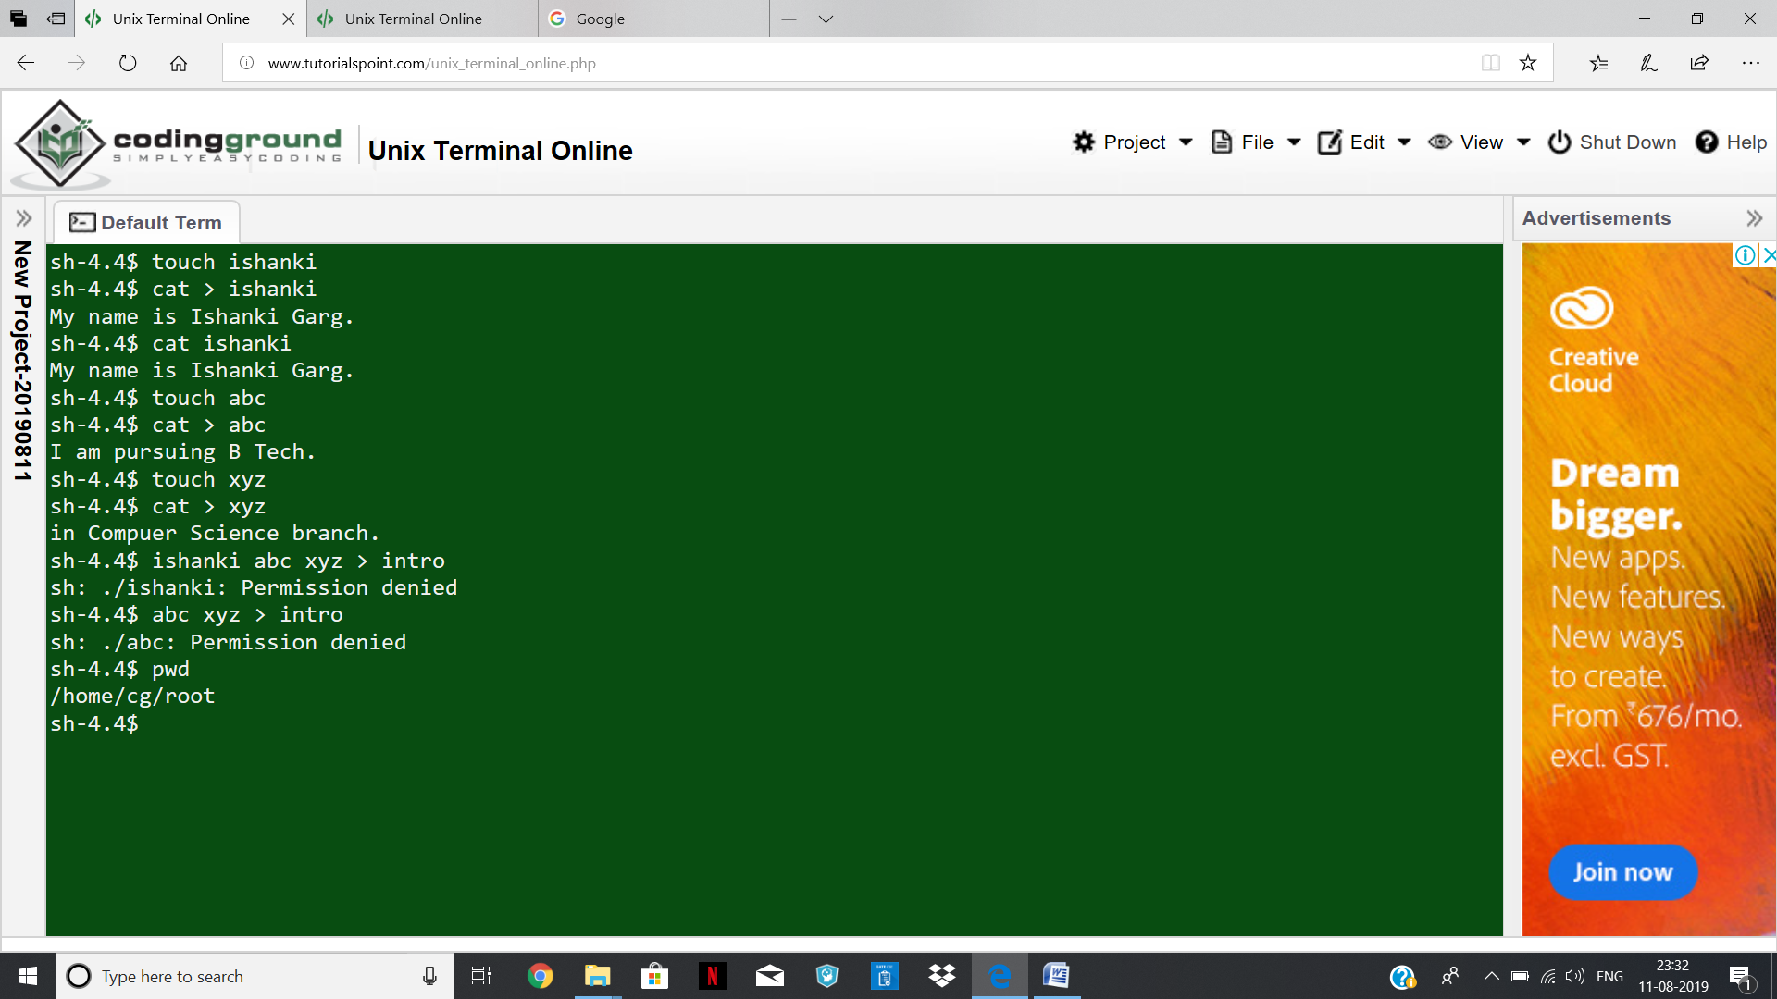

1. **ls**

It provides listing of the files in your current working directory except hidden files.

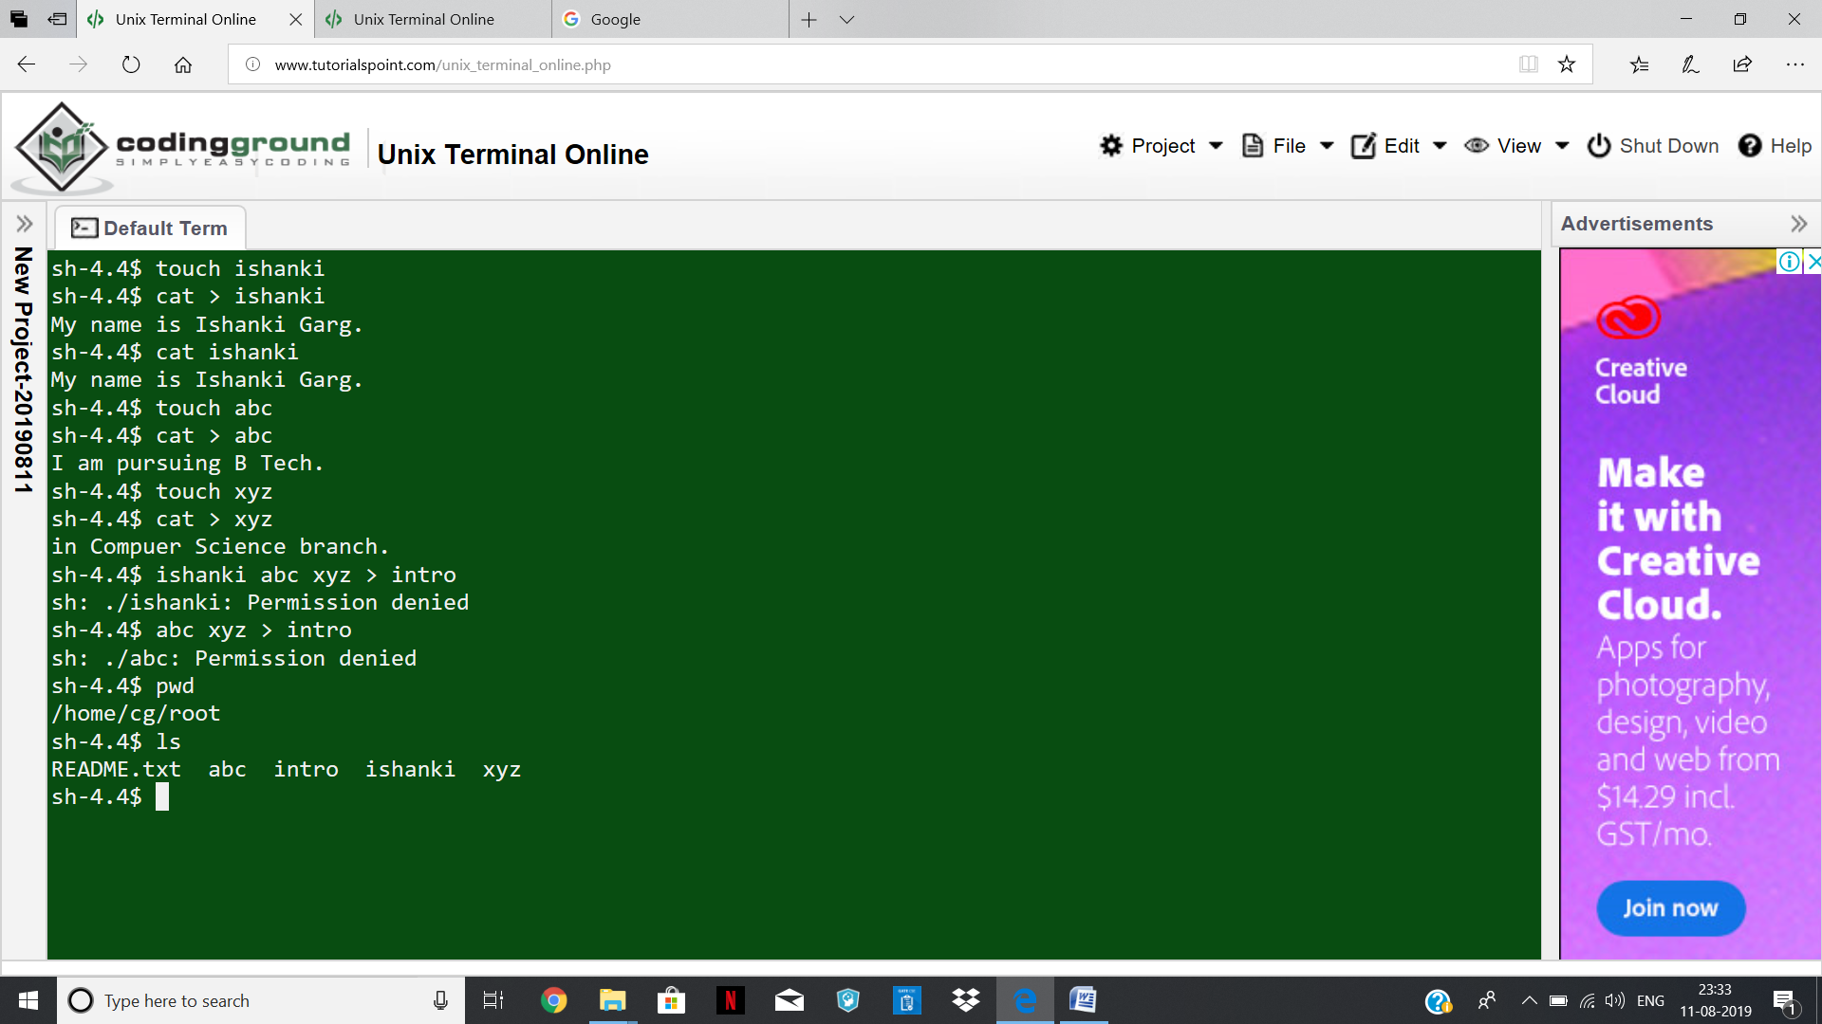

ls-a command report information about all files, including hidden files.

ls-l provide a long listing of information about the files and directories it reports. The long listing will provide important information about file permissions, user and group ownership, file size, and creation date.

ls –al combines the functionality of the –a and –l options.

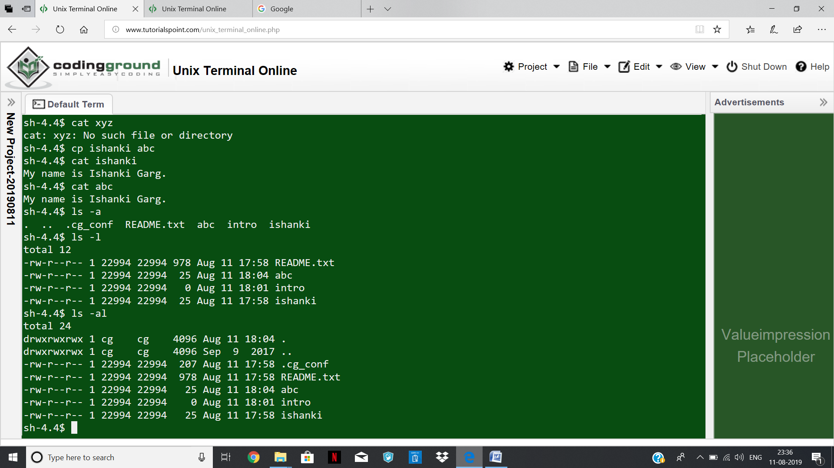

1. **mv**

mv command moves the file abc into the file xyz.

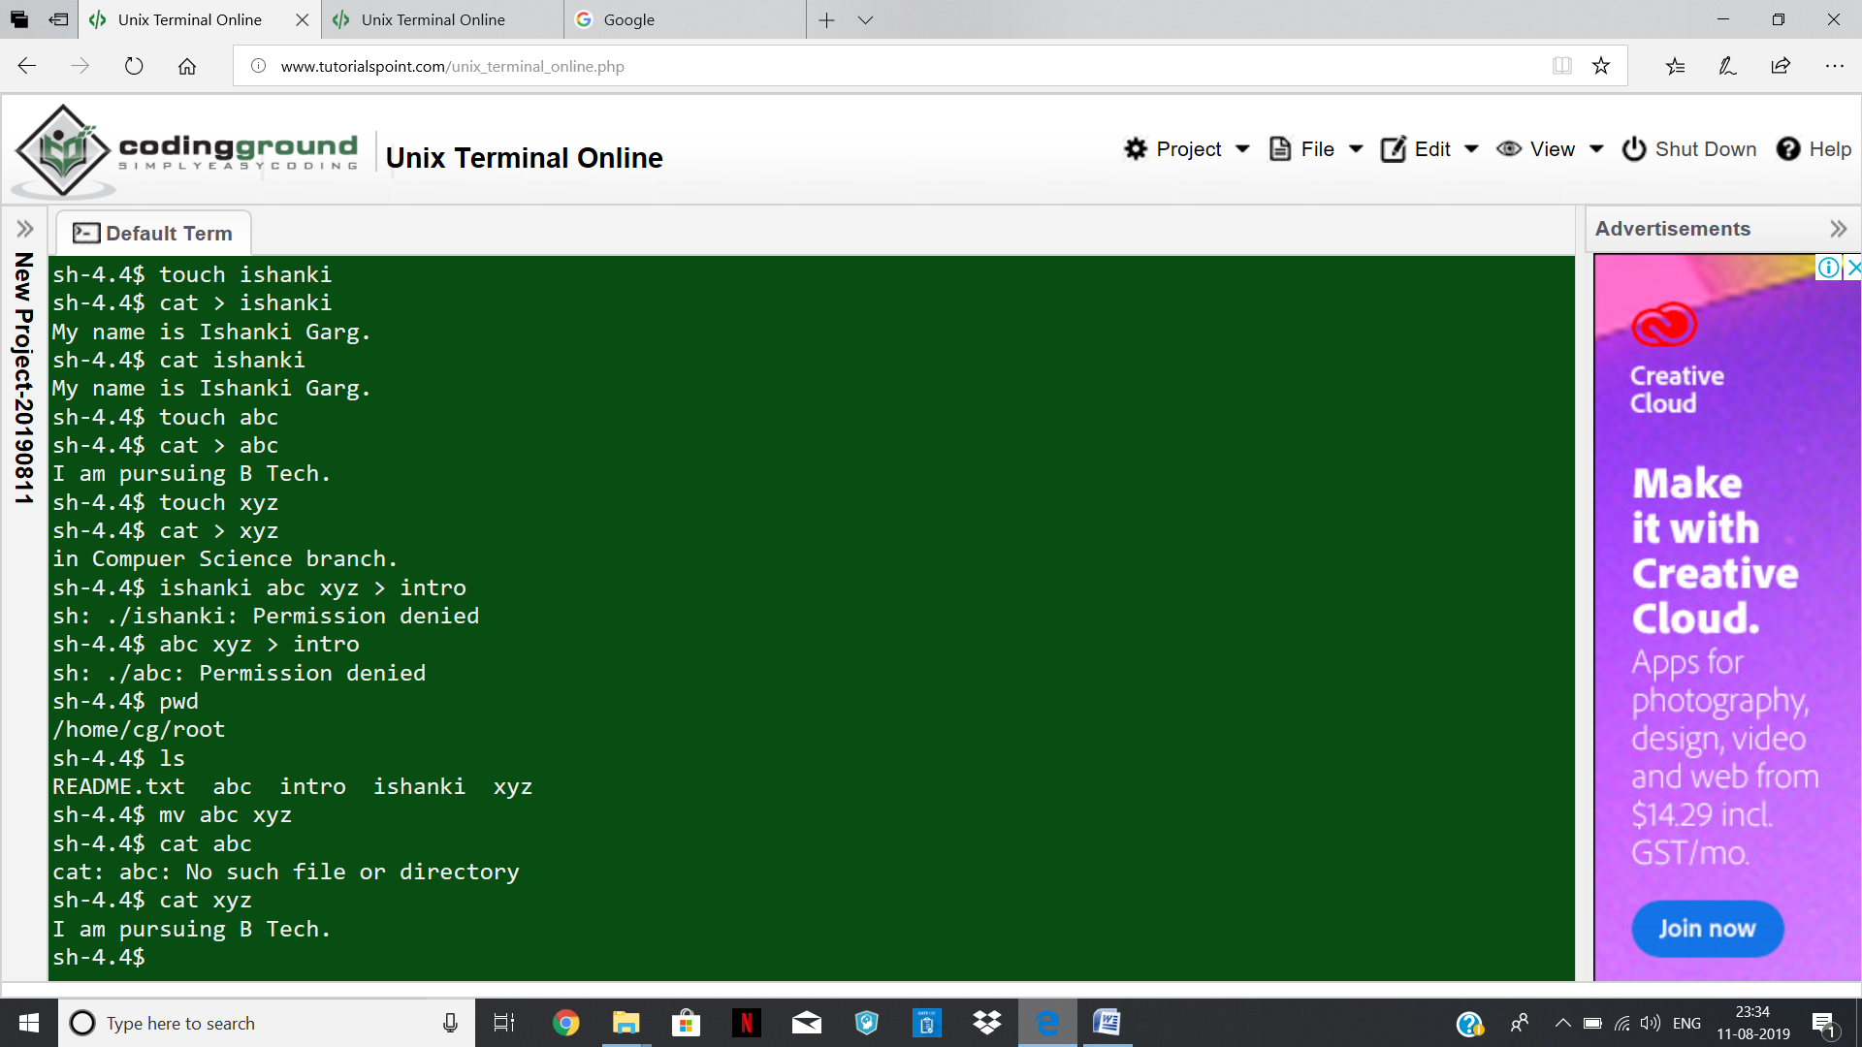

1. **rm**

rm command deletes the file named xyz.

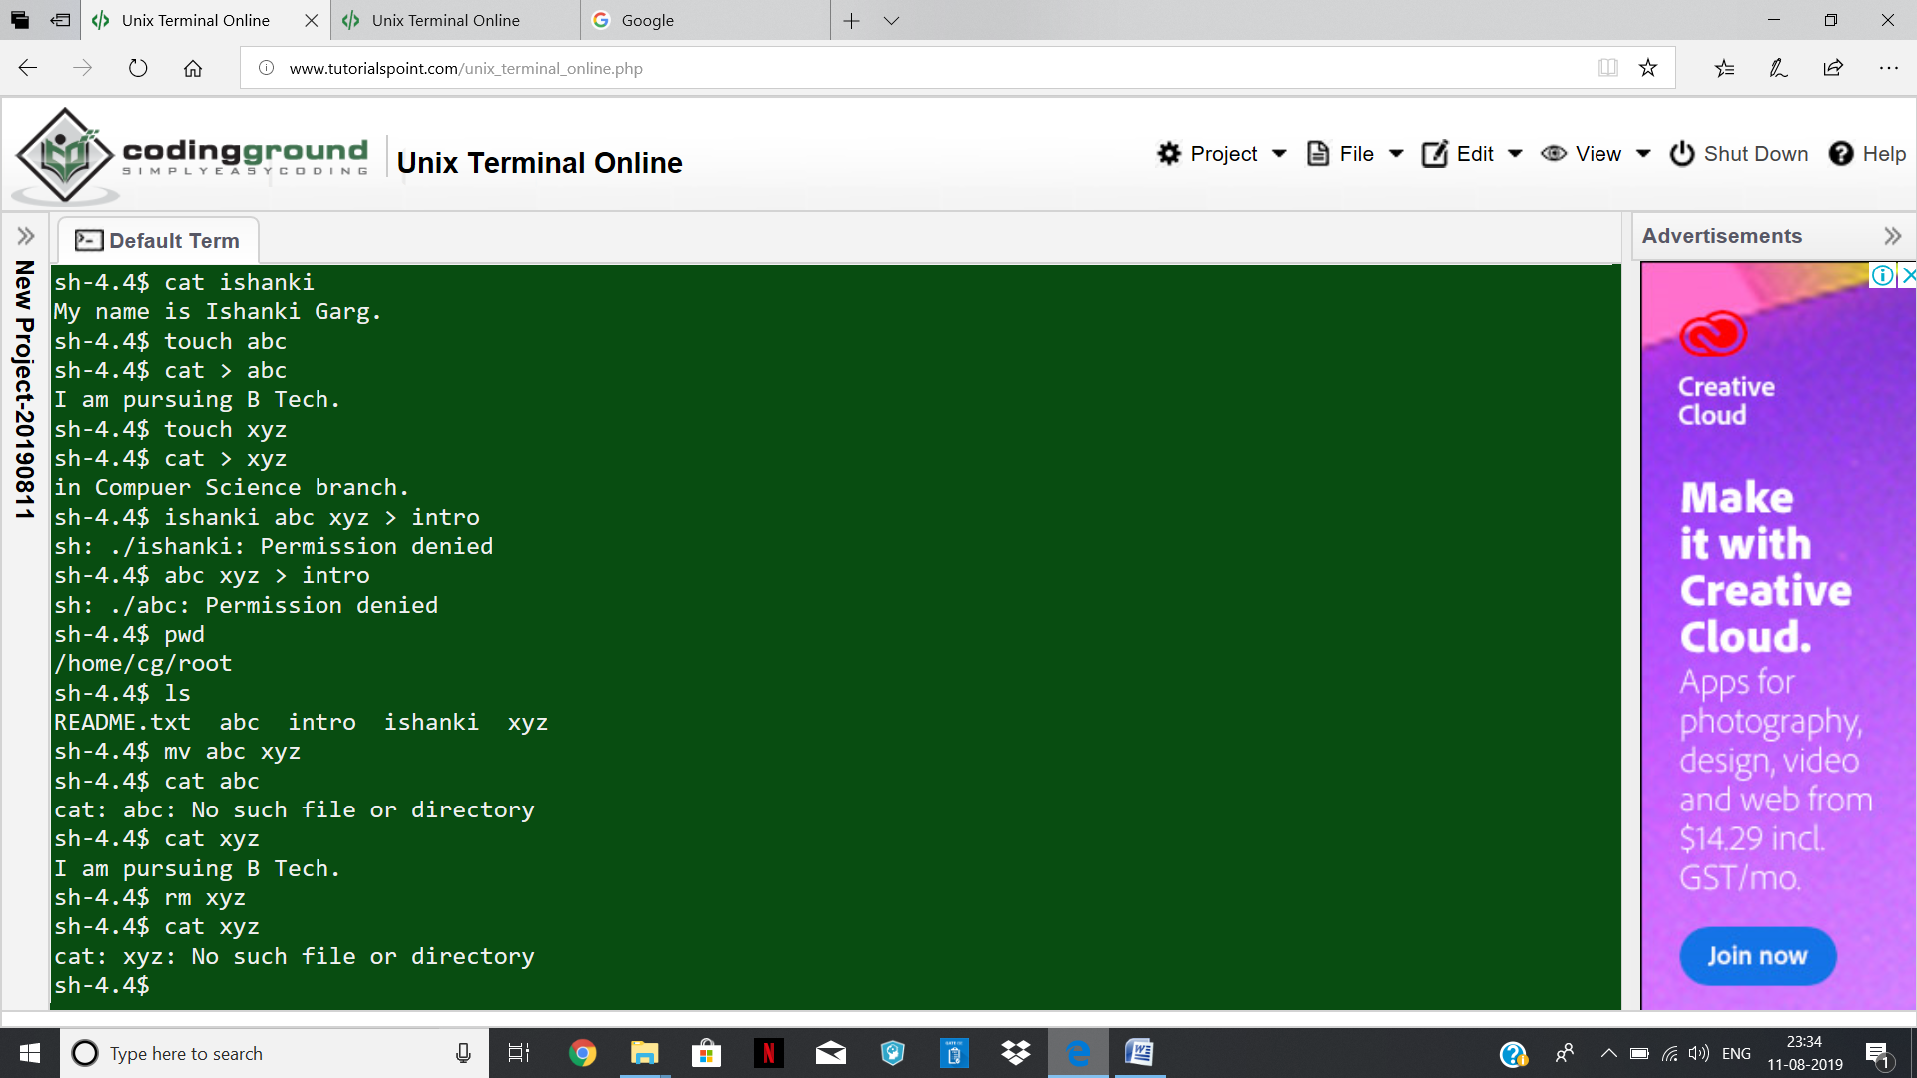

1. **cp**

cp command copies ishanki file to file abc.

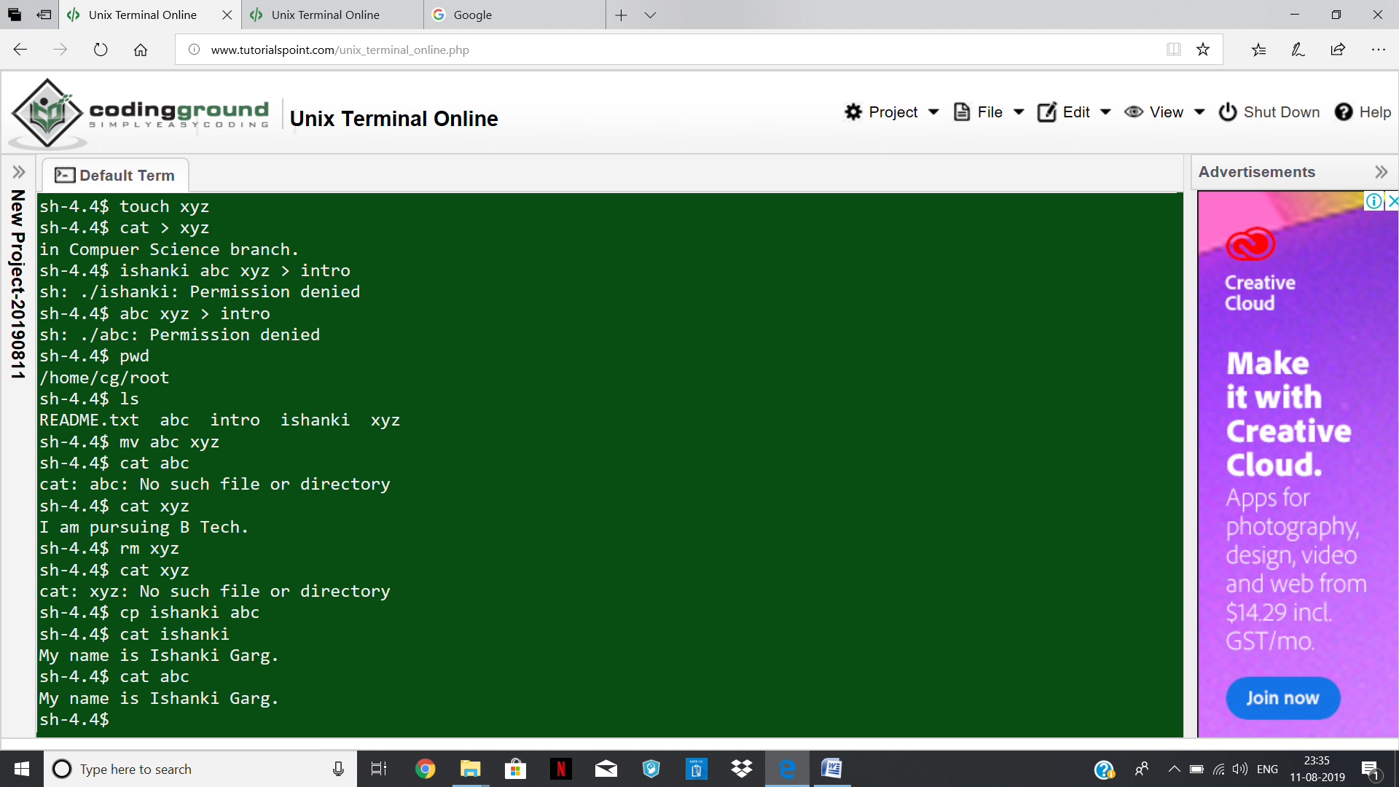

1. **grep**

grep ‘abc’ /home/cg/root/abc command searches for all occurences of the text string ‘abc’ in the /home/cg/root/abc file.

grep ‘^abc’ /home/cg/root/abc command searches for all occurences of the text string ‘abc’ in the /home/cg/root/abc file but also requires that the “a” in the “abc” be in the first column of each record.

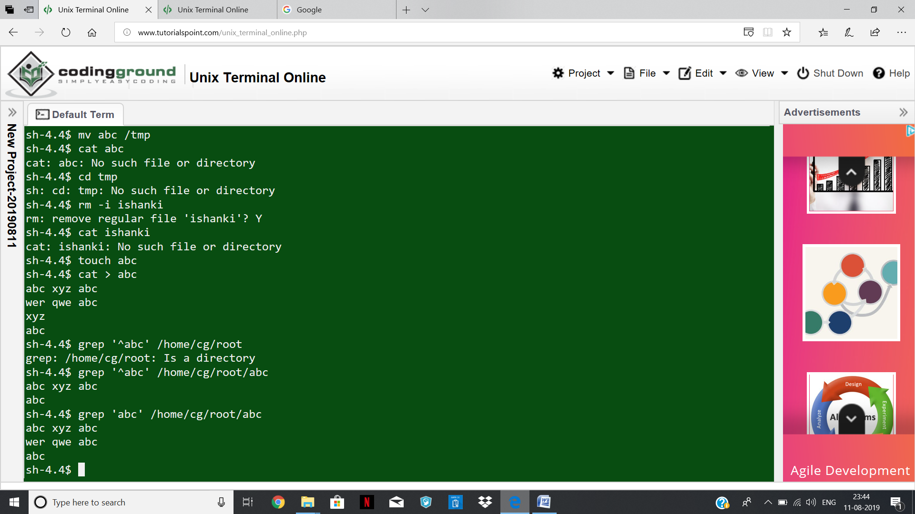

1. **mkdir**

mkdir a1 command creates a new directory named “a1” in the current directory.

Mkdir /home/cg/root/a1/temp command creates a directory “tmp” in the directory “a1”.

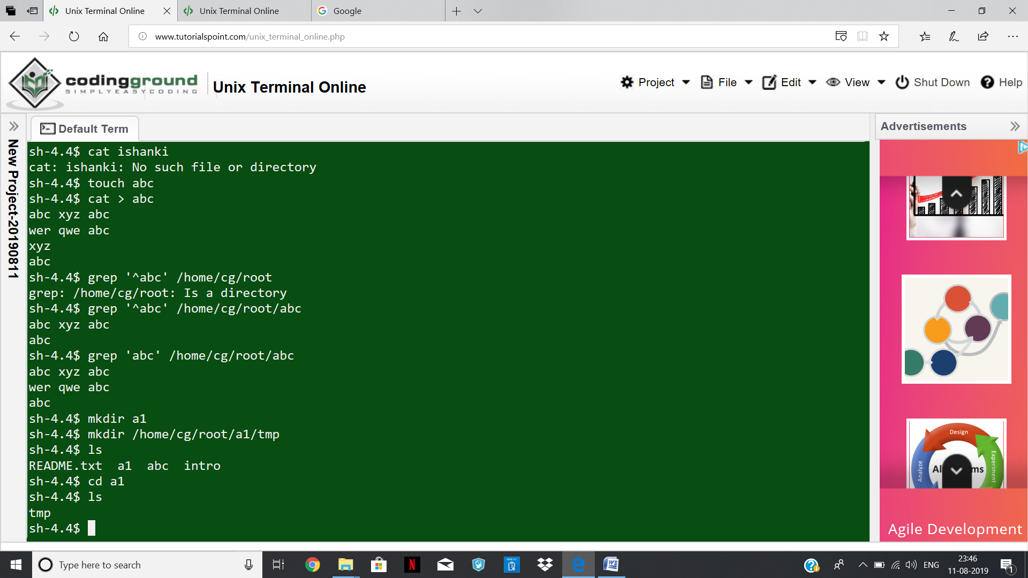

1. **rmdir**

rmdir command removes the directory tmp if it is empty.

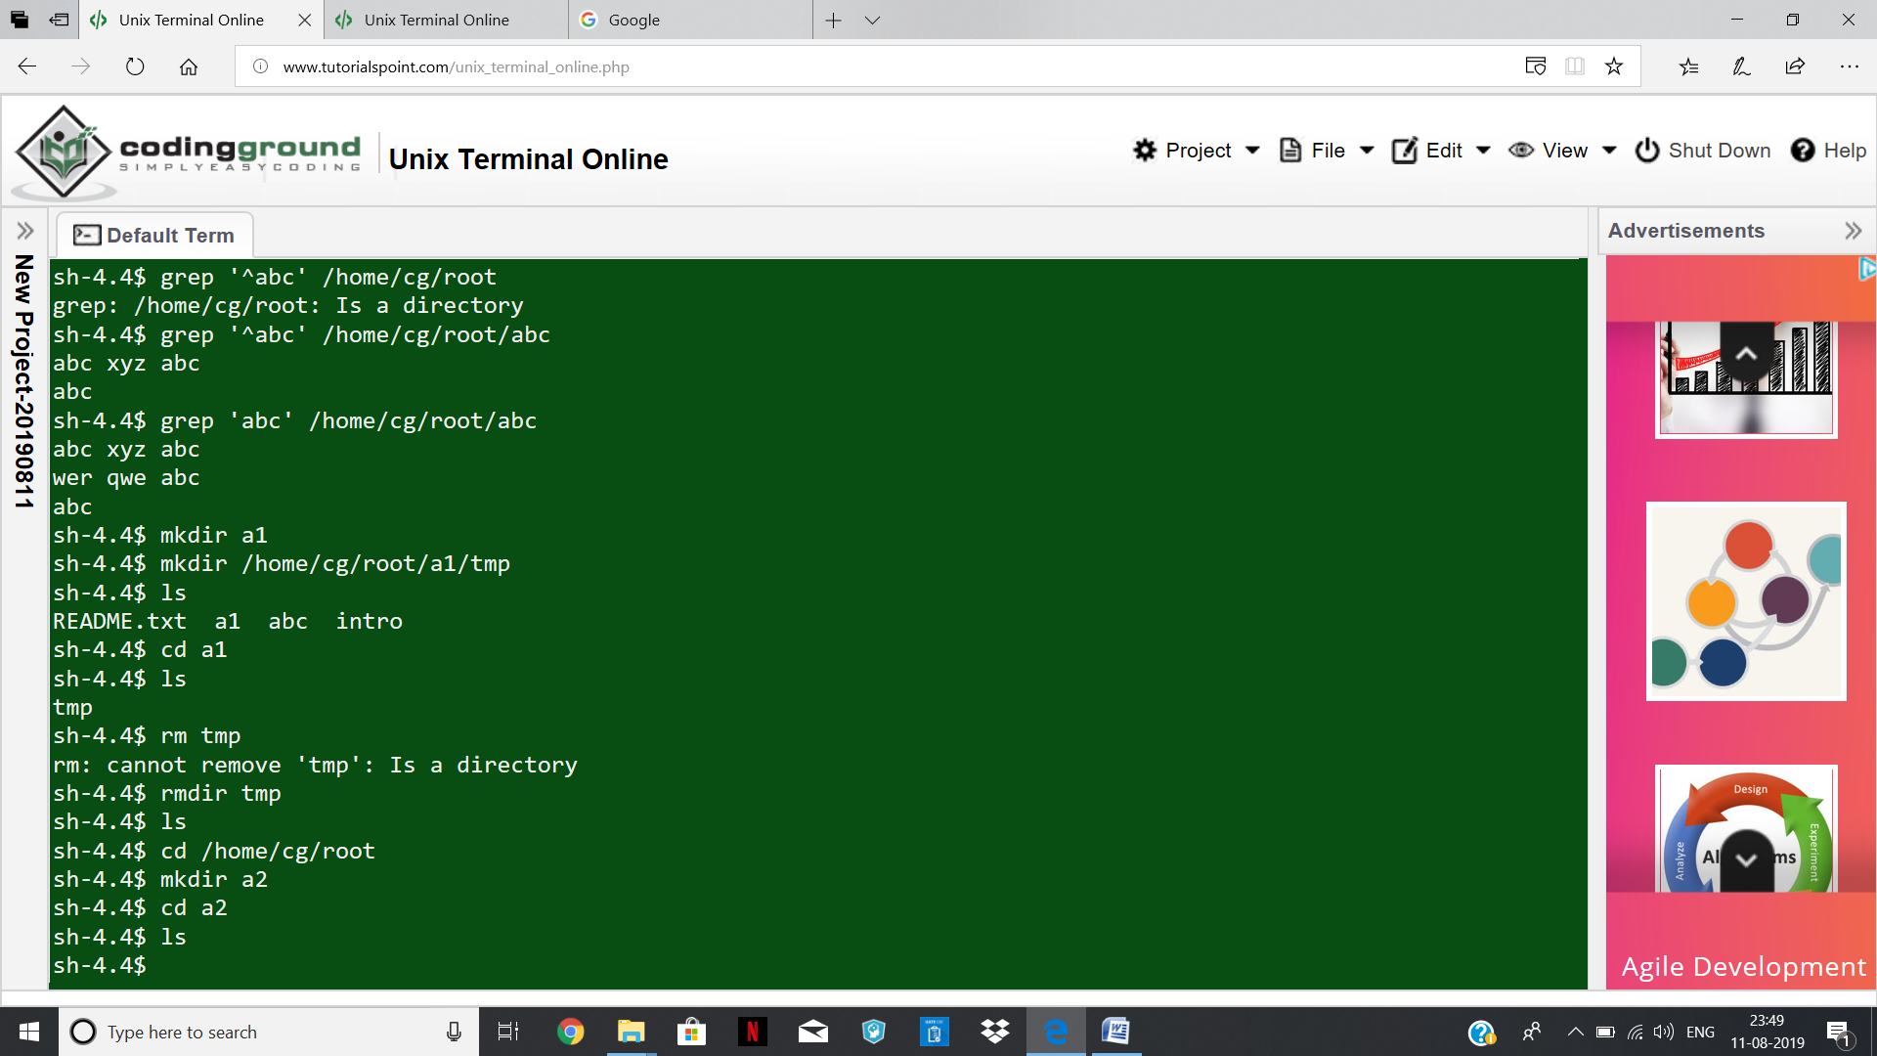

1. **cd**

cd a2 command moves you to the “a2” directory. Now “a2 “ becomes the current working directory.



1. **ps**

The “ps” command by itself shows the minimal information about the processes we are running.

The –f argument tells the ps command to supply full information about the processes it dispalys.

The –e argument tells the ps command to show every process running on the system.

The –e and –f arguments are combined like this to show full information about every process running on the system.

Because the output normally scroll off the screen , the output of the ps –ef command is often piped into the more command. The more command lets you view one screenful of information at a time.

